Experiment No. 1 (Write a program to find the GCD of two numbers.)

Name: Mayank yadav (0832CS191102)

Input:

Output:

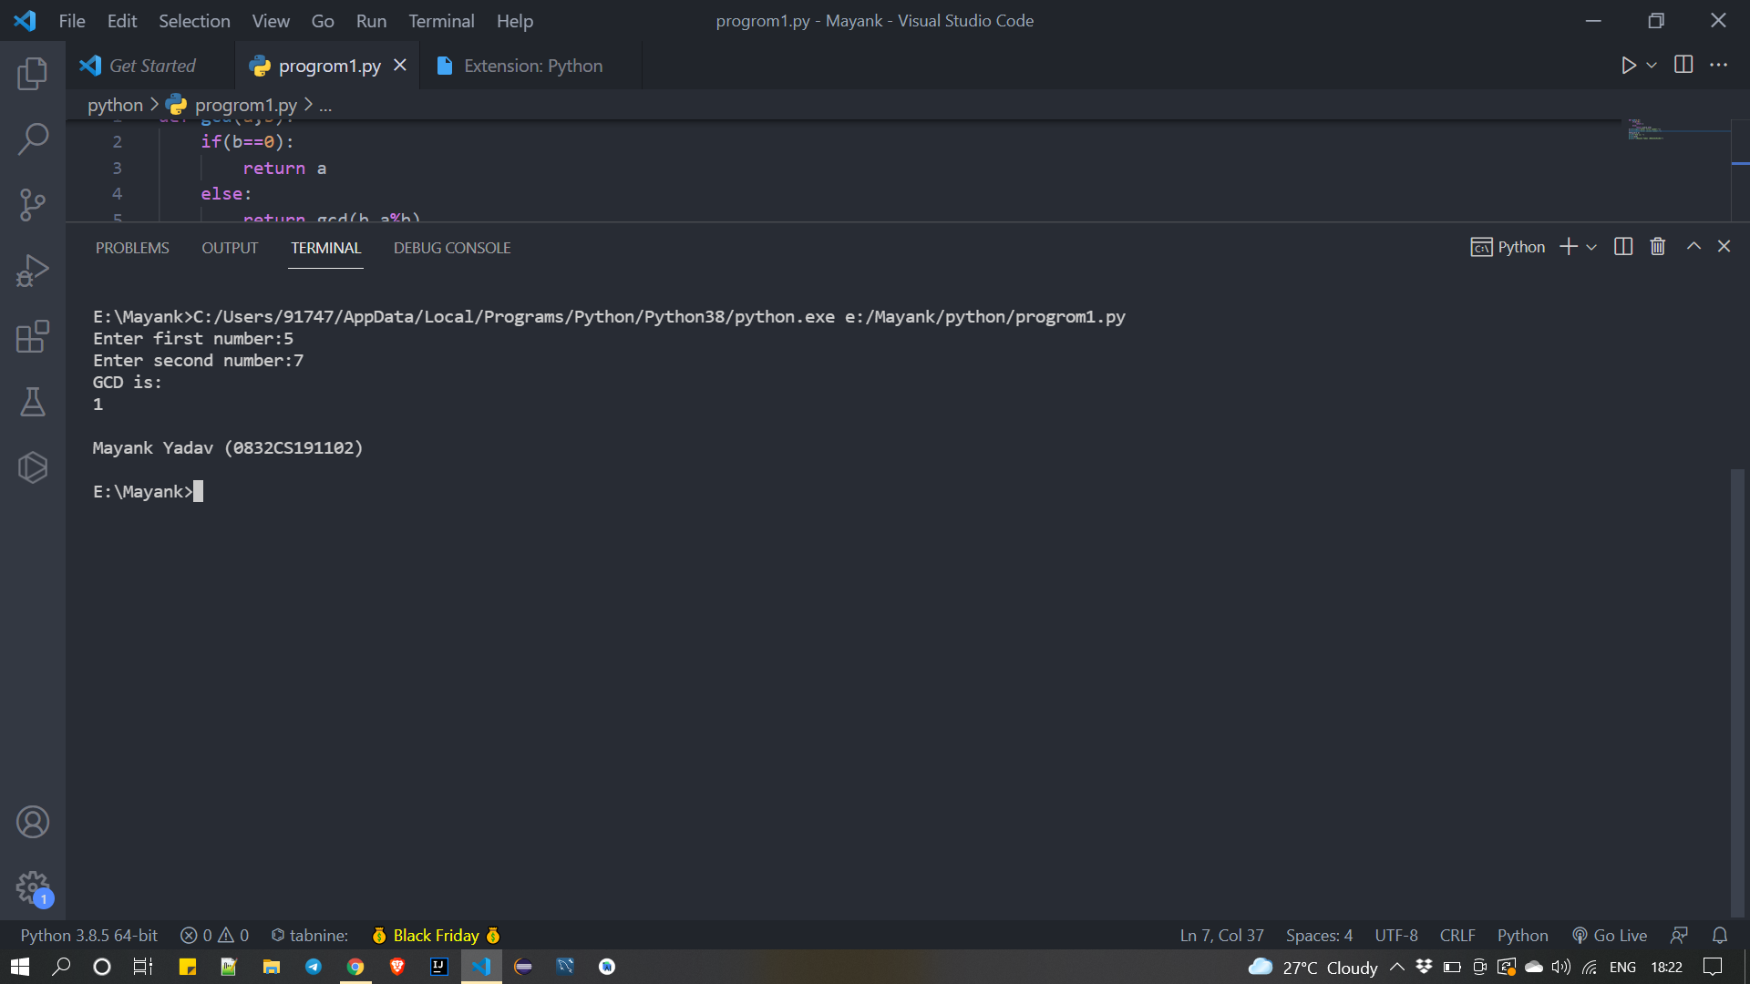

Experiment no: 2 (Write a program to find the square root of a number by Newton's method.)

Name: Mayank yadav (0832CS191102)

Input:

Output:

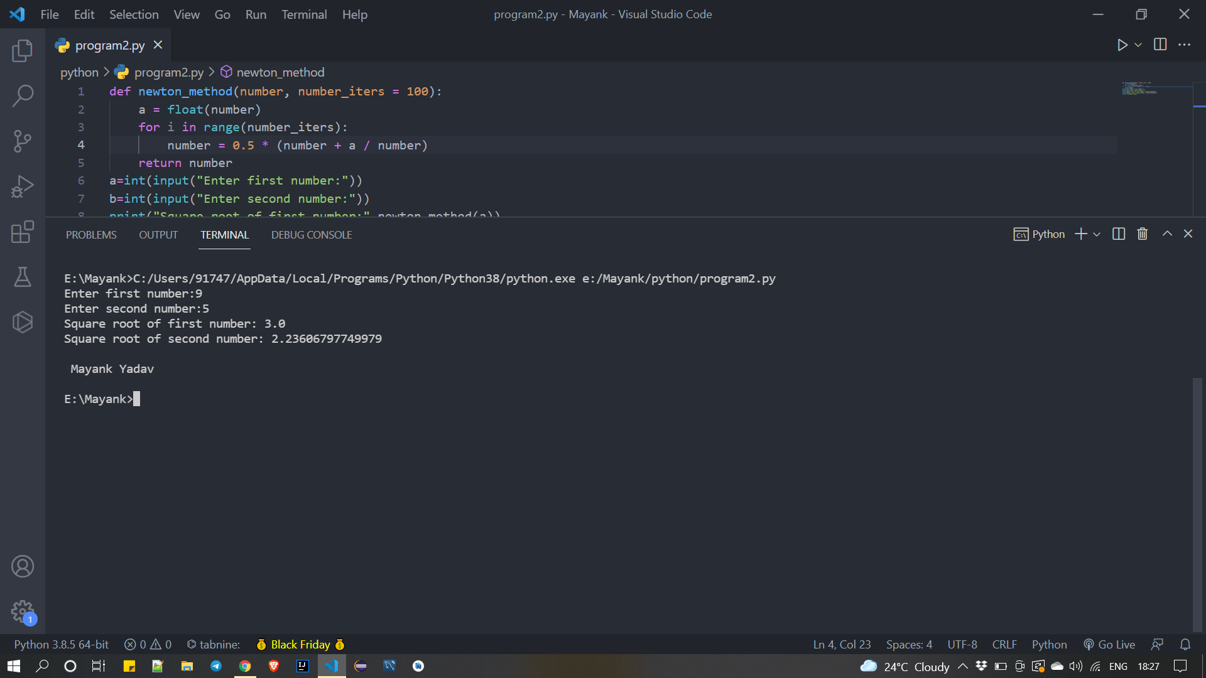

Experiment No. 3(Write a program to find the exponentiation of a number.)

Name: Mayank yadav (0832CS191102)

Input:

Output:

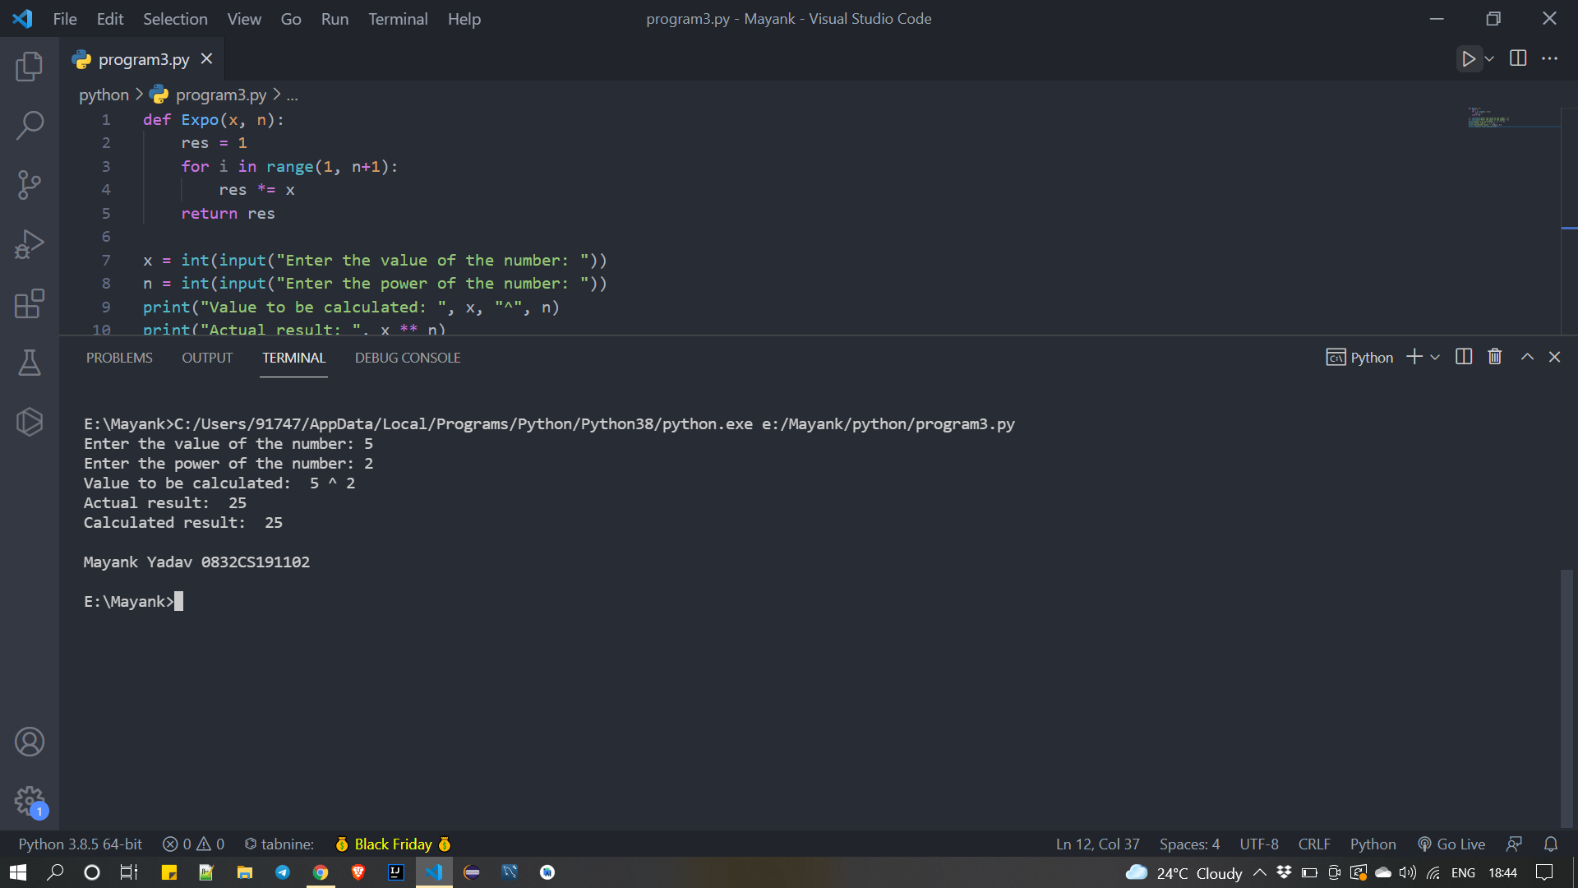

Experiment No. 4(Write a program to find the number with the maximum value from a list of numbers.)

Name: Mayank yadav (0832CS191102)

Input:

Output:

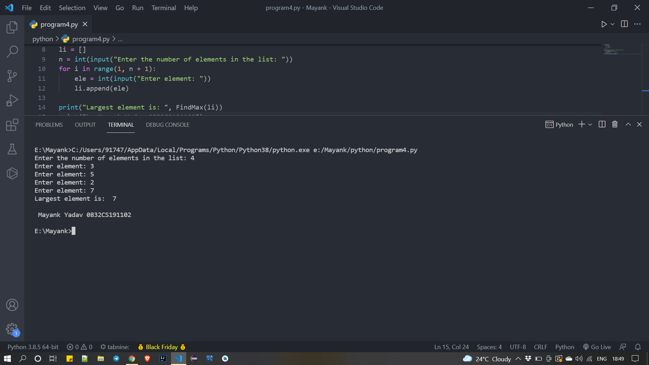

Experiment No. 5(Write a program to implement linear search.)

Name: Mayank yadav (0832CS191102)

Input:

Output:

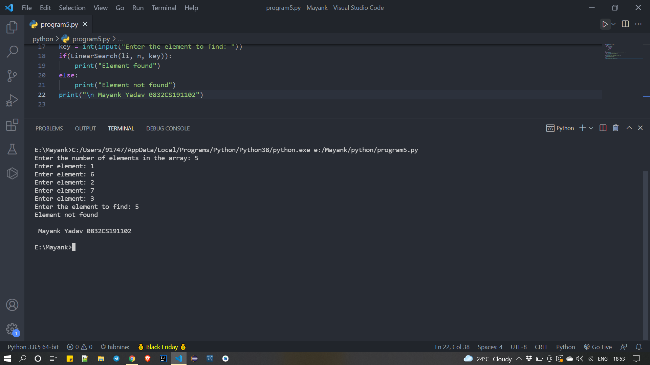

Experiment No. 6(Write a program to implement binary search.)

Name: Mayank yadav (0832CS191102)

Input:

Output:

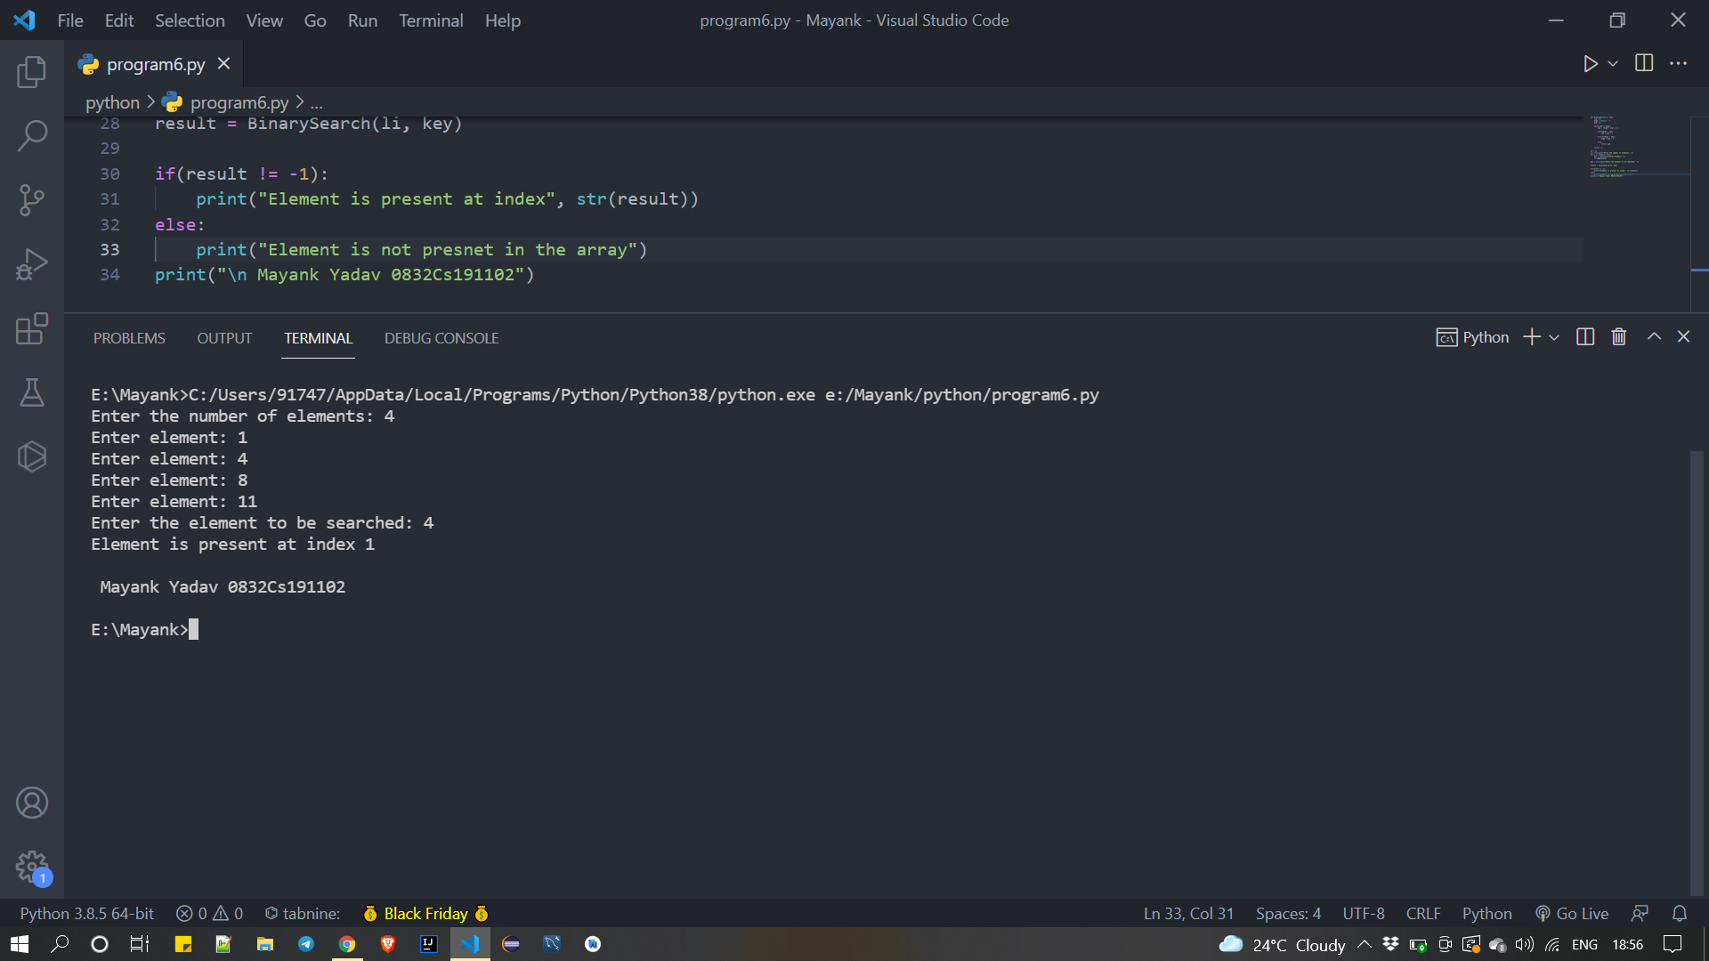

Experiment No. 7(Write a program to implement Selection Sort.)

Name: Mayank yadav (0832CS191102)

Input:

Output:

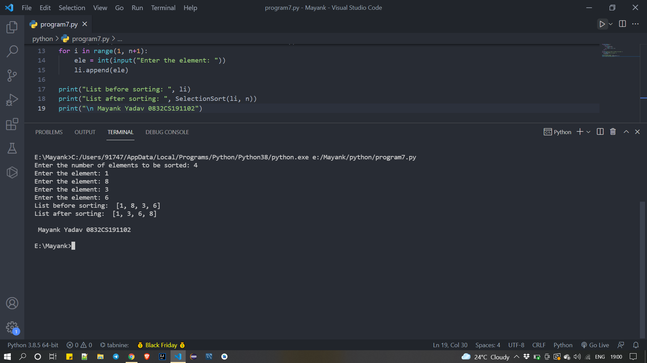

Experiment No. 8(Write a program to implement Insertion Sort.)

Name: Mayank yadav (0832CS191102)

Input:

Output:

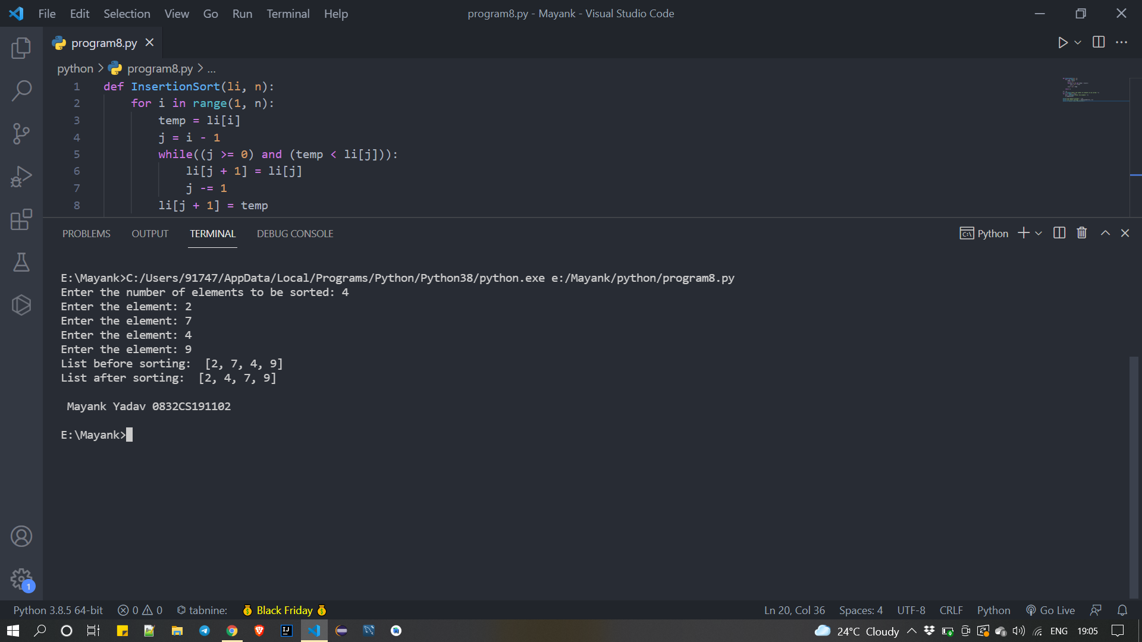

Experiment No. 9(Write a program to implement Merge Sort.)

Name: Mayank yadav (0832CS191102)

Input:

Output:

